CS 4375

ASSIGNMENT 2

Names of students in your group:

Nikita Istomin nyi180000

Number of free late days used: 2   
Note: You are allowed a **total** of 4 free late days for the **entire semester**. You can use at most 2 for each assignment. After that, there will be a penalty of 10% for each late day.

Please list clearly all the sources/references that you have used in this assignment.

# Part 1

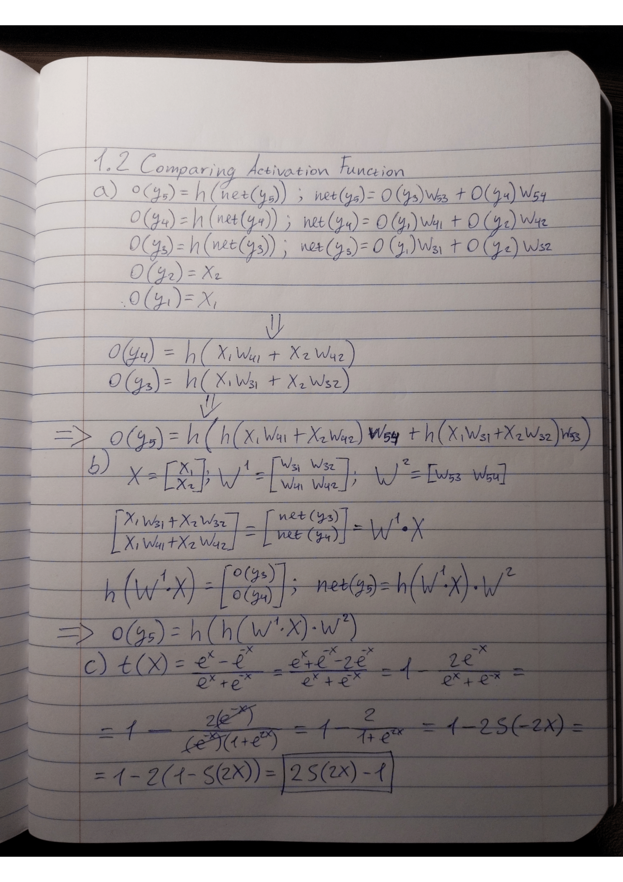

# Part 2

Sorted by Test Accuracy:

Summary:

I had 11 different models, with all except for one, with completely identical performance. 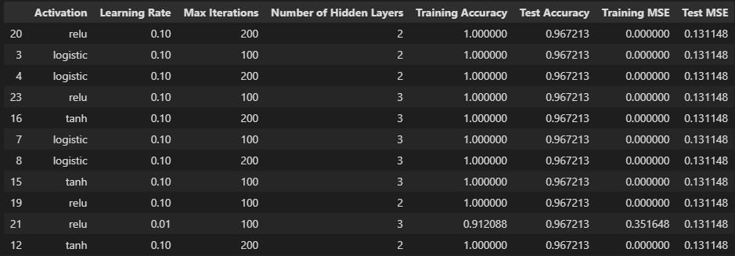

Something that all models that scored identically have in common is learning rate of 0.1 .

We can also observe that models with lower learning rate of 0.01 and lower max iterations of 100 scored generaly lower than everything else. That makes perfect sense because models with lower learning rate need more iterations to complete building a model.

There were no decicive winners in the activation function category, which leads me to conclude that any activation function can be used effectively, given a good combination of learning rate and max iterations.

I couldn’t find any corelation between number of hidden layers to model accuracy.